Name: ANIKET MANKARI

Q 1 Java program to print welcome message.

**package** librarymgt;

**public** **class** welcome {

**public** **static** **void** main(String[] args) {

System.***out***.println("welcome");

}

}

Output:

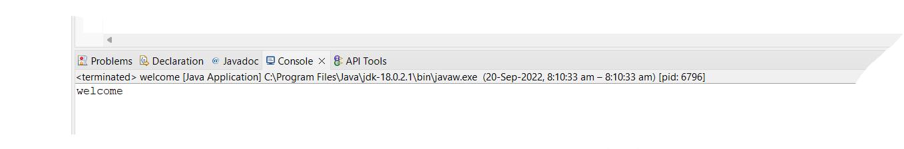

Q 2 Java program to print sum of three float numbers

**package** librarymgt;

**import** java.util.*;

**public** **class** addthreefloatno {

**public** **static** **void** main(String[] args) {

**float** a,b,c,sum;

System.***out***.println("enter three numbers");

**try** (Scanner i = **new** Scanner(System.***in***))

{

a=i.nextFloat();

b=i.nextFloat();

c=i.nextFloat();

}

sum=a+b+c;

System.***out***.println("sum of numbers = "+" "+sum);

}

}

Output:

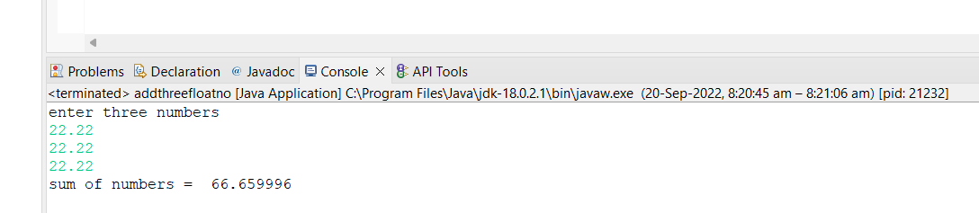

Q 3 Java Program to Swap Two Numbers.

**package** librarymgt;

**import** java.util.*;

**public** **class** swapingofno {

**public** **static** **void** main(String[] args) {

**int** a,b,temp;

System.***out***.println("enter two numbers");

Scanner i=**new** Scanner(System.***in***);

a=i.nextInt();

b=i.nextInt();

System.***out***.print("the two no are before swapping a= "+a );

System.***out***.println(" "+"b="+b);

temp=b;

b=a;

a=temp;

System.***out***.println("the two no after swapping ");

System.***out***.println("a="+a);

System.***out***.println("b="+b);

}

}

Output:

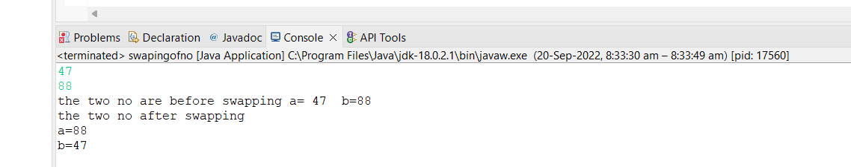

Q 4 Wap to check if number is even or odd.

**package** librarymgt;

**import** java.util.*;

**public** **class** Noevenorodd {

**public** **static** **void** main(String[] args) {

**int** number;

System.***out***.println("enter the number");

**try** (Scanner i = **new** Scanner(System.***in***)) {

number=i.nextInt();

}

**if**(number%2==0)

System.***out***.println("number is even");

**else**

System.***out***.println("number is oddd" );

}

}

Output:

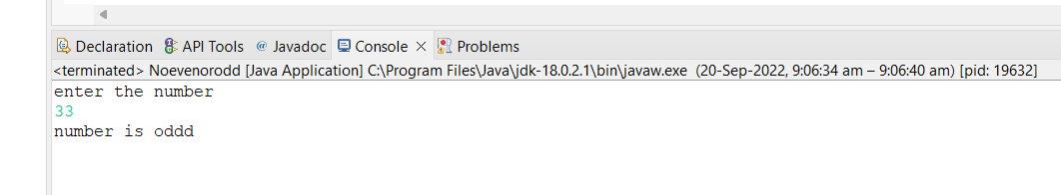

Q 5 wap to check from three given number  that whether a number is greater than or equal to 20 and less than other numbers .print appropriate message .

**package** assignment1;

**public** **class** greateramongthree {

**public** **static** **void** main(String[] args) {

**int** a=10,b=17,c=15;

**if**(a>b && a>c && a>=20)

System.***out***.println("the number a is greatest among three and a>=20");

**else** **if**(b>a && b>c && b>=20)

System.***out***.println("the number b is greatest among three and b>=20");

**else** **if**(c>a && c>b && c>=20)

System.***out***.println("the number c is greatest among three and c>=20");

**else**

System.***out***.println("the numbers are less than 20");

}

}

Output:

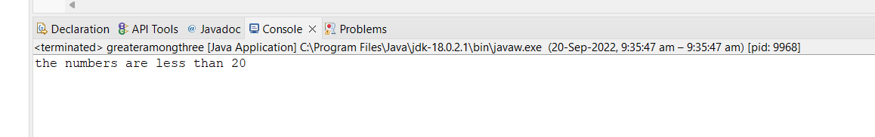

Q 6 wap to check if sales of a person is greater than 10000 then eligible for bonus   
else not eligible calculate bonus as 20% of sales .

**package** assignment1;

**public** **class** salesofperson {

**public** **static** **void** main(String[] args) {

**int** sales;

sales=25000;

**if**(sales>=10000)

System.***out***.println("elligible for bonus. Bonus=" + 0.2*sales);

**else**

System.***out***.println("Not eligible for bonus");

}

}

Output:

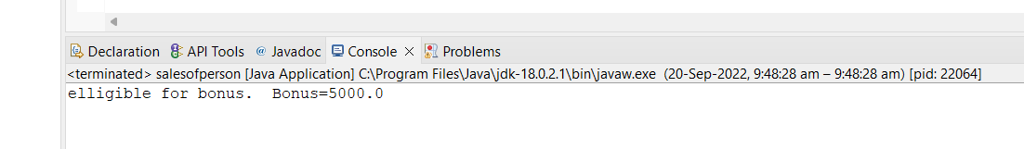

Q 7 wap to check if two given integer value is in range of 18 and 100 print eligible for voting else not eligible.

**package** assignment1;

**import** java.util.*;

**public** **class** voting {

**public** **static** **void** main(String[] args) {

**int** i,j;

Scanner p= **new** Scanner(System.***in***);

System.***out***.println("enter two numbers");

i=p.nextInt();

j=p.nextInt();

**if**(i>18&&j>18)

System.***out***.println("elligible for voting");

**else**

System.***out***.println("not elligible for voting");

}

}

Output:

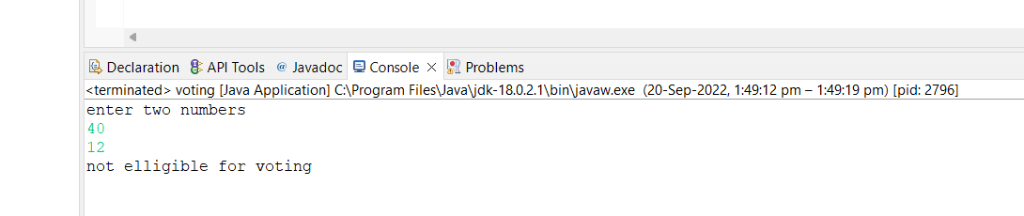

Q 8.wap to print average of  given five subjects marks of student and check if average >=40 print Pass else print fail.

**package** assignment1;

**public** **class** averageOfStudentMarks {

**public** **static** **void** main(String[] args) {

**int** a=35,b=55,c=30,d=50,e=60,avg=0;

avg=(a+b+c+d+e)/5;

**if**(avg>=40)

System.***out***.println("Student is pass.average marks are "+avg);

**else**

System.***out***.println("Student is fail");

}

}

Output:

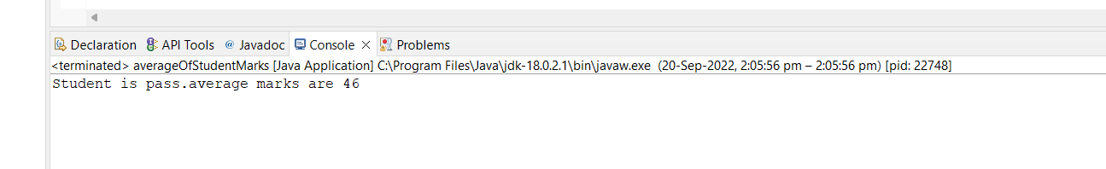

Q 9 WAP to ask name ,age and salary of an employee and print on console.

**package** assignment1;

**import** java.util.Scanner;

**import** java.util.stream.IntStream;

**public** **class** employeeDetails {

**public** **static** **void** main(String[] args) {

String a;

**int** b;

**float** c;

System.***out***.println("enter the employee name,age,salary");

**try** (Scanner i = **new** Scanner(System.***in***))

{

a=i.nextLine();

b=i.nextInt();

c=i.nextFloat();

}

System.***out***.println("name:"+a);

System.***out***.println("age:"+b);

System.***out***.println("salary:"+c);

}

}

Output:

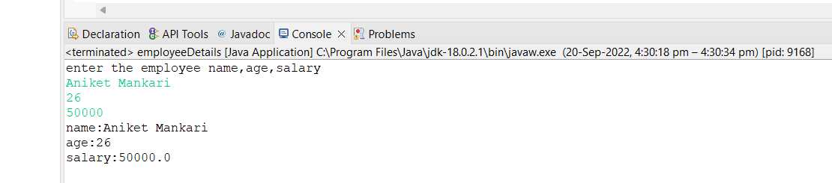

Q 10 wap that ask two numbers from user and print greater number among two.

**package** assignment1;

**import** java.util.*;

**public** **class** largeAmongTwoNo {

**public** **static** **void** main(String[] args) {

**int** a,b;

System.***out***.println("enter two numbers");

**try** (Scanner i = **new** Scanner(System.***in***)) {

a=i.nextInt();

b=i.nextInt();

}

**if**(a>b)

System.***out***.println("a is greater. a= "+a);

**else**

System.***out***.println("b is greater. b= "+b);

}

}

Output:

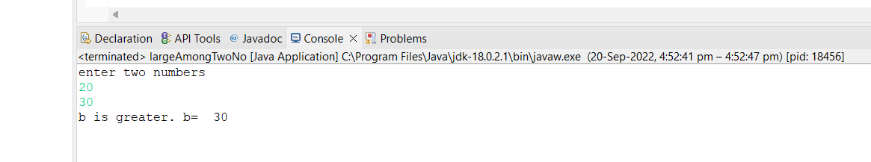

Q 11  wap to ask product name and price of product from user and calculate discount i.e   
if price > 2000 then discount is 10 percent of price  else discount is 7 % of price.

**package** assignment1;

**import** java.util.*;

**public** **class** discountPrice {

**public** **static** **void** main(String[] args) {

// wap to ask product name and price of product from user and calculate discount i.e

//if price > 2000 then discount is 10 percent of price else discount is 7 % of price.

String name;

**float** price,discount;

System.***out*** .println("Enter the name of product and price");

Scanner i = **new** Scanner(System.***in***);

name=i.nextLine();

price=i.nextFloat();

**if**(price>=20000)

{

discount=(**float**) (price*0.1);

price=price-discount;

System.***out***.println("discount is 10%. discount= "+ discount+" price= "+price);

}

**else**

{

discount=(**float**) (price*0.07);

price=price-discount;

System.***out***.println("discount is 7%.discount= "+ discount+" price= "+price);

}

}

}

Output:

